MAMMOTH COMMUNITY WATER DISTRICT – PERSONNEL SERVICES
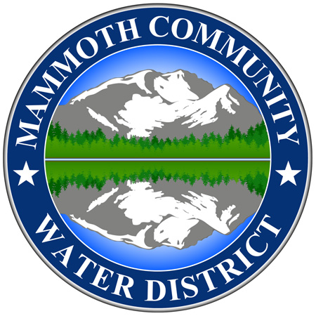
SUPPLEMENTAL EMPLOYMENT APPLICATION QUESTIONNAIRE
___________________________________________________________________________
Executive Assistant
Recruitment No. 26-012
Salary Range: $52.59 – $63.11 Hourly
Date Opened: Monday, 09/28/2026
Filing Deadline: Open Until Filled
Job Type: General and Open
Recruitment Contact: Renee English
_________________________________________________________________________________
SUPPLEMENTAL APPLICATIONS ARE TO BE SUBMITTED BY EMAIL ONLY ALONG WITH THE OTHER REQUIRED APPLICATION MATERIALS

Name: ______________________________

Please submit responses to the following questions along with the required application materials on and/or before the filing deadline. Attach additional sheets if necessary.

Questions:

- Do you have at least three years of performing administrative and analytical assignments in program development and operations, personnel, public and media relations, and/or general business administration?

☐ Yes ☐ No If yes, please provide details/examples:

From (mm/dd/yyyy) to (mm/dd/yyyy) | Employer & Description of Experience

- Do you have at least two years in a supervisory or lead capacity?

☐ Yes ☐ No If yes, please provide details/examples:

From (mm/dd/yyyy) to (mm/dd/yyyy) | Employer & Description of Experience

- Do you have at least thirty semester units or a bachelor’s degree from an accredited college or university?
☐ Yes ☐ No

If yes, can you provide a copy of transcripts and/or your degree upon request?
☐ Yes ☐ No
- If selected for an interview, you must attend in person at Mammoth Community Water District offices located at 1315 Meridian Boulevard, Mammoth lakes, CA 93546. Will you be able to attend an interview in person?

☐ Yes ☐ No

- Describe specifically how your past experience is applicable to this position.
Response:

Certification of Applicant:

Read this statement carefully before signing: I hereby certify that all the information provided in the Supplemental Application Questionnaire is true, correct and complete to the best of my knowledge. I understand and agree that any misstatements or omissions of material fact herein will cause forfeiture on my part of all rights to employment by Mammoth Community Water District.
By typing in my name, I acknowledge signing this supplemental application:

Signature: ___________________________________________
Date: ____________________________

